Skill-1:
Step 1: Open PowerShell as Administrator
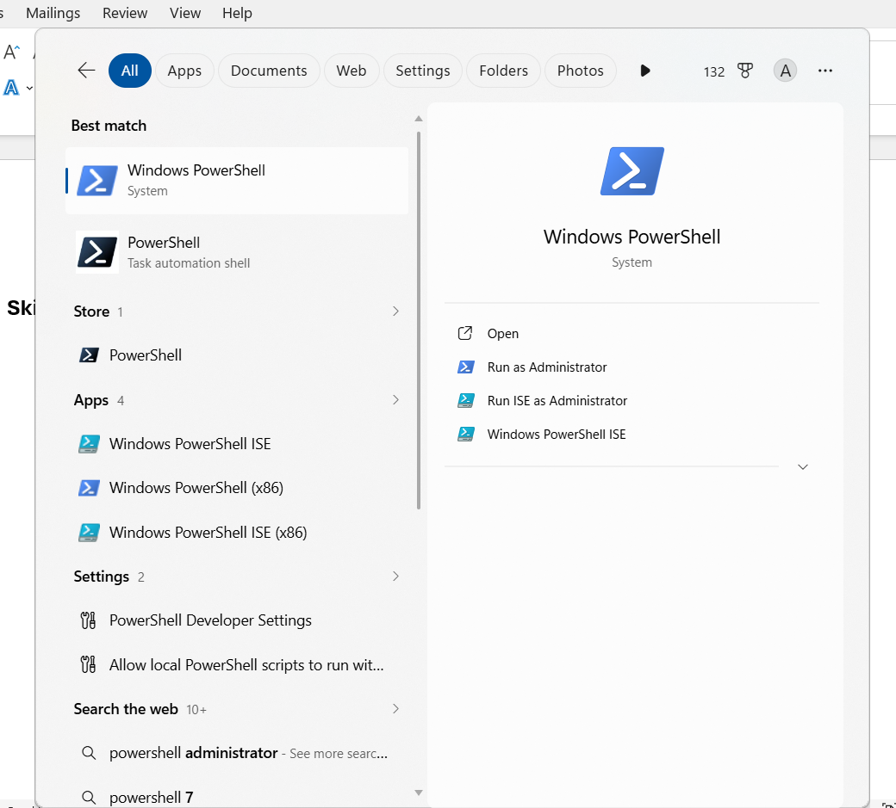

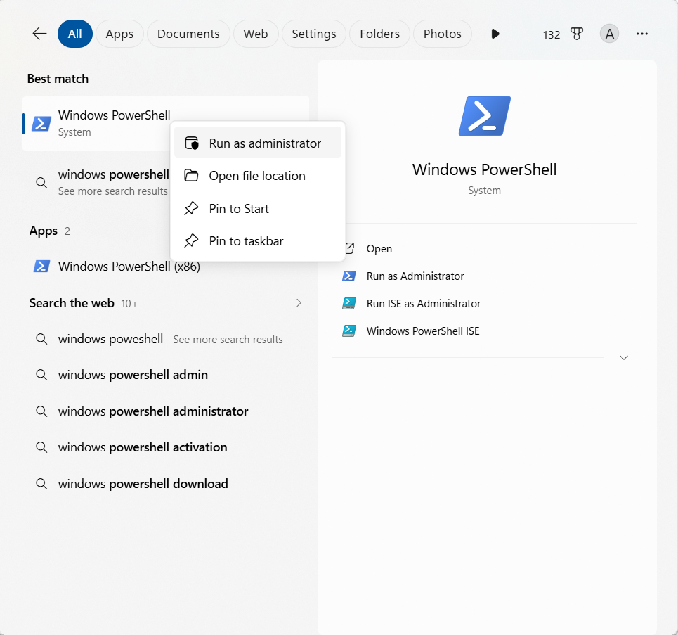

Step-3:wsl install
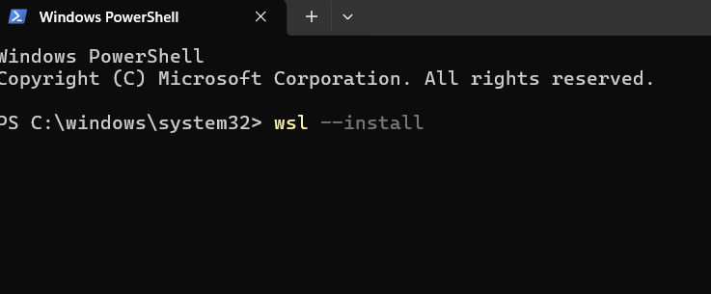
Step 3: Restart Your Computer
Step 4: Complete Ubuntu Setup
Step 5: Create a Password
Step 6: Update Ubuntu


Step 7: Install GCC (C Compiler)
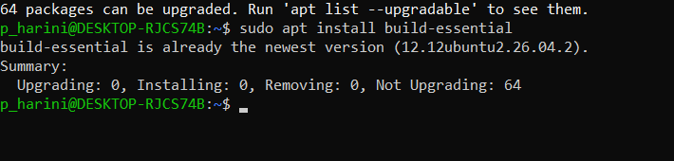

Step 8: Verify the Installation
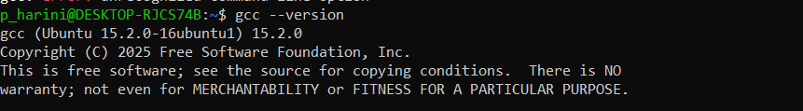
Step 9: Create Your C Program
Step 10: Compile the Program
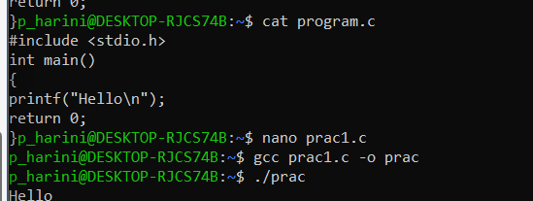

History:
